Pap test device controlled break tip

BY: ASHAR AHMED JAVED

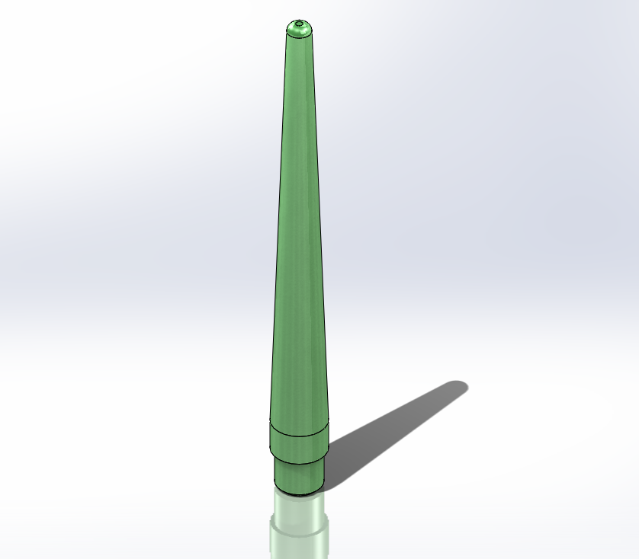

PURPOSE:

to enhance the design to prevent the balloon insertion tip from accidentally puncturing the recipient, it is decided that you should focus on designing the tip to fail (break) within a pressure limit of 4 lbs.

This study utilizes a provided design and FEA-Finite Element Analysis software was used to identify undesirable feature characteristics through computer simulation. This document presents chronologically the process of identification of engineered features.

**Material**: Delrin (MPa Threshold 63 ≤)

|  |  |  |  |  |
| --- | --- | --- | --- | --- |
| |  | | --- | |  |   **Model name: Needle (1)**  **Current Configuration: Default** | | | |
| **Solid Bodies** | | | |
| **Document Name and Reference** | **Treated As** | **Volumetric Properties** | **Document Path/Date Modified** |
| **Cut-Extrude3** | **Solid Body** | **Mass:0.000190148 kg**  **Volume:1.34857e-07 m^3**  **Density:1,410 kg/m^3**  **Weight:0.00186345 N** | **D:\New Life\Learning SOLIDWORKS\Vertanux1 Simulations\Lab 3\Needle (1).SLDPRT**  **Mar 17 21:09:42 2025** |

|  |  |  |  |  |  |  |  |  |  |  |  |  |  |  |  |  |  |  |  |  |  |  |  |  |  |  |  |  |  |  |  |  |  |  |  |  |  |  |  |  |
| --- | --- | --- | --- | --- | --- | --- | --- | --- | --- | --- | --- | --- | --- | --- | --- | --- | --- | --- | --- | --- | --- | --- | --- | --- | --- | --- | --- | --- | --- | --- | --- | --- | --- | --- | --- | --- | --- | --- | --- | --- |
| **Loads and Fixtures**  | **Fixture name** | **Fixture Image** | **Fixture Details** | | --- | --- | --- | | **Fixed-1** |  | |  |  | | --- | --- | | Entities: | **1 face(s)** | | Type: | **Fixed Geometry** | | | **Resultant Forces**   |  |  |  |  |  | | --- | --- | --- | --- | --- | | **Components** | **X** | **Y** | **Z** | **Resultant** | | **Reaction force(N)** | **5.72605e-05** | **44.4855** | **-0.00140448** | **44.4855** | | **Reaction Moment(N.m)** | **0** | **0** | **0** | **0** | | | |  | **Load name** | **Load Image** | **Load Details** | | --- | --- | --- | | **Force-2** |  | |  |  | | --- | --- | | Entities: | **1 face(s), 1 Solid Body (s)** | | Type: | **Apply normal force** | | Value: | **10 lbf** | | |

ANALYSIS – A: Von Mises

**Needle**

Results: The **Needle** seems to break within our yield limit.

During analysis we discovered the 10 LBF torque with a material yield strength of MPa 63 exceeds by a factor of 2000 times at the critical places.

SUMMARY: PASS.

| Name | Type | Min | Max |
| --- | --- | --- | --- |
| Stress1 | VON: von Mises Stress | 2.285e+05N/m^2  Node: 8425 | 4.653e+08N/m^2  Node: 7282 |
| **Needle (1)-Static 1-Stress-Stress1** | | | |

ANALYSIS – B: Displacement

Results: The **Needle** appears to be designed well about yield.

SUMMARY: PASS

| Name | Type | Min | Max |
| --- | --- | --- | --- |
| Displacement1 | URES: Resultant Displacement | 0.000e+00mm  Node: 1 | 7.847e-01mm  Node: 255 |
| **Needle (1)-Static 1-Displacement-Displacement1** | | | |

SUMMARY: With the optimized design, we managed to get the failure under with 4 lbs force while keeping the material cost and design alteration to a minimum!